**Individual Brainstorming**

**Darcy**

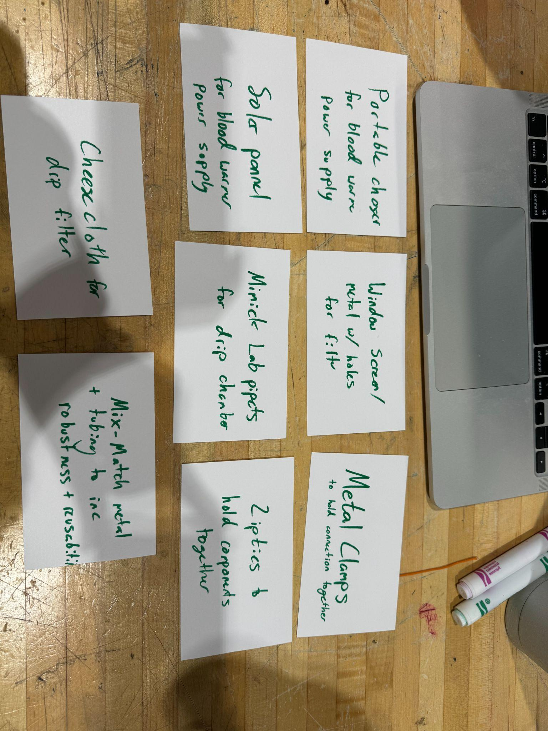

* Portable charger
  + Considers the power outages in Malawi
  + Meets the design criteria of using low-power
  + Meets the design criteria of being compact
  + Does not meet the design criteria of resource availability in Malawi
* Window screen/metal mesh
  + Meets the design criteria of sterilizable, reusability, and mechanical robustness
  + Depending on the material, this idea could fail in terms of resource availability and cost
* Metal connections
  + Meets the design criteria for sterilizable, reusability, mechanical robustness
  + This could not provide an air-tight seal, depending on whether there is no additional connections, such as glue
* Solar panel
  + Again, this accounts for power outages in Malawi
  + Meets design criteria for using low power and resource availability
  + Fails the design criteria of being compact
* Lab pipette for drip chamber
  + This material would allow for the flexibility we want in the chamber
  + This idea meets none of our major design criteria
* Zip ties for flow regulation
  + This allows for proper flow modulation
  + Meets the design criteria for sterilizable, reusability, cost, and ease of use
  + Fails the design criteria for resource availability and mechanical robustness
* Cheesecloth for filter
  + This would provide the design to filter out blood clots, however, the holes may be too large to efficiently filter.
  + Meets the design criteria for resource availability and cost
  + Fails the design criteria for sterilizable, reusability, and mechanical robustness
* Metal tubing in some locations
  + This idea was mainly to think of ways to make our tubing more robust
  + Meets the design criteria for sterilizable, reusability, mechanical robustness, and cost
  + Might fail the design criteria for air-tight seal due to additional connections

**Hannah**

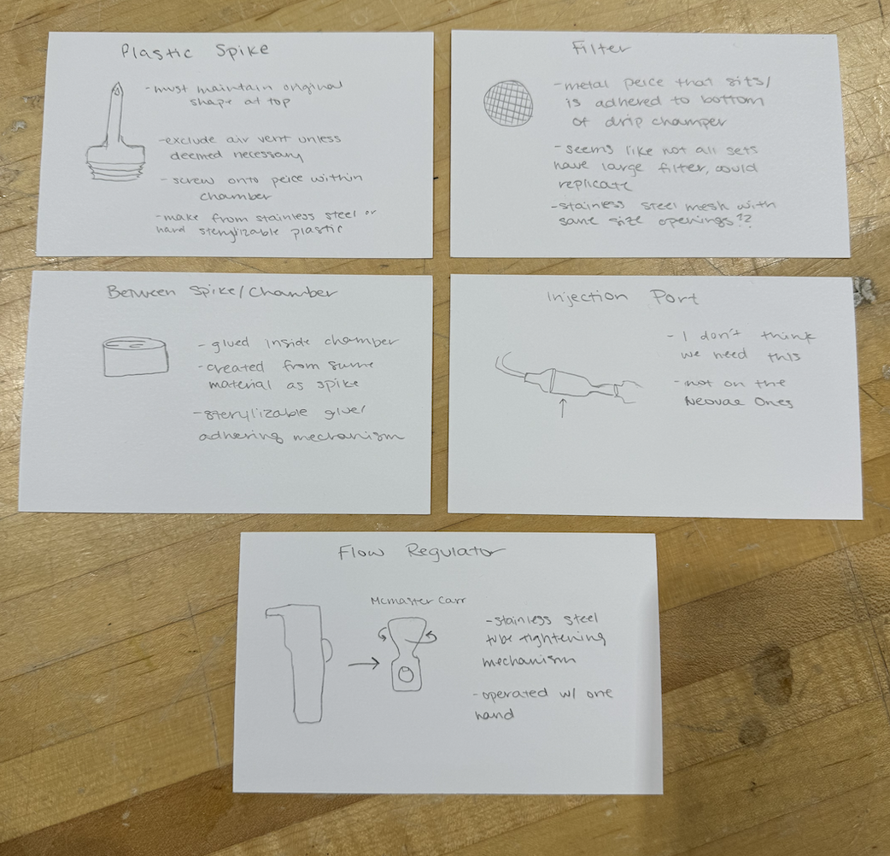

**Jason**

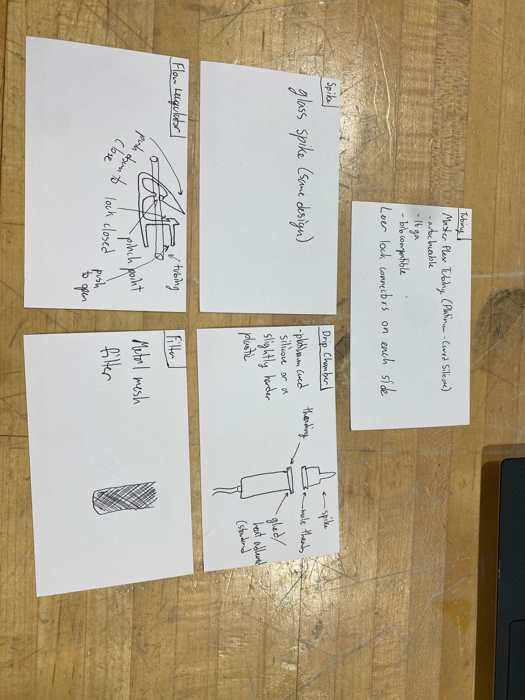

* Masterflex Tubing:
  + I found this steralizable tubing through research and it seemed perfect for our project
  + Meets design criteria of being autoclaveable, and biocompatible
  + The only part not considered is if the luer locks will hinder the sterilization process
* A Glass spike was thought to be a spike made of an easily sterilizable material.
  + Meets the design criteria of sterilizable and would be compatible with the blood bags
  + Does not consider the damage that could be done to the blood bag if too sharp
  + Does not consider durability and the likelihood that it will be broken in the clinic
* The Drip Chamber idea was thought to use the same material of the tubing that i found and make the spike attach to the drip chamber using a screw-on set with hard plastic or metal to make the chamber open and sterilizable.
  + Meets the design criteria of sterilizable and easy to assemble.
  + Does not consider what kind of adhesive we will use to attach the components
* The Flow regulator design was a design that I had seen online that i later found out was called a Robert Clip.
  + Meets the design criteria of being easy to use and sterilizable if made out of the right material.
  + Is not sufficient to provide a range of flow modulation in both increasing and decreasing flow
* The filter design was just a thought to make a metal mesh filter
  + This meets the design criteria of being a sterilizable material, however, does not consider whether the mesh size or porosity of the mesh will affect the sterility of the mesh
  + Would need to consider corrosion and other factors that would play into choosing the right metal
  + Also does not consider geometry for this filter which would have a large impact on the design.

**Michaela**

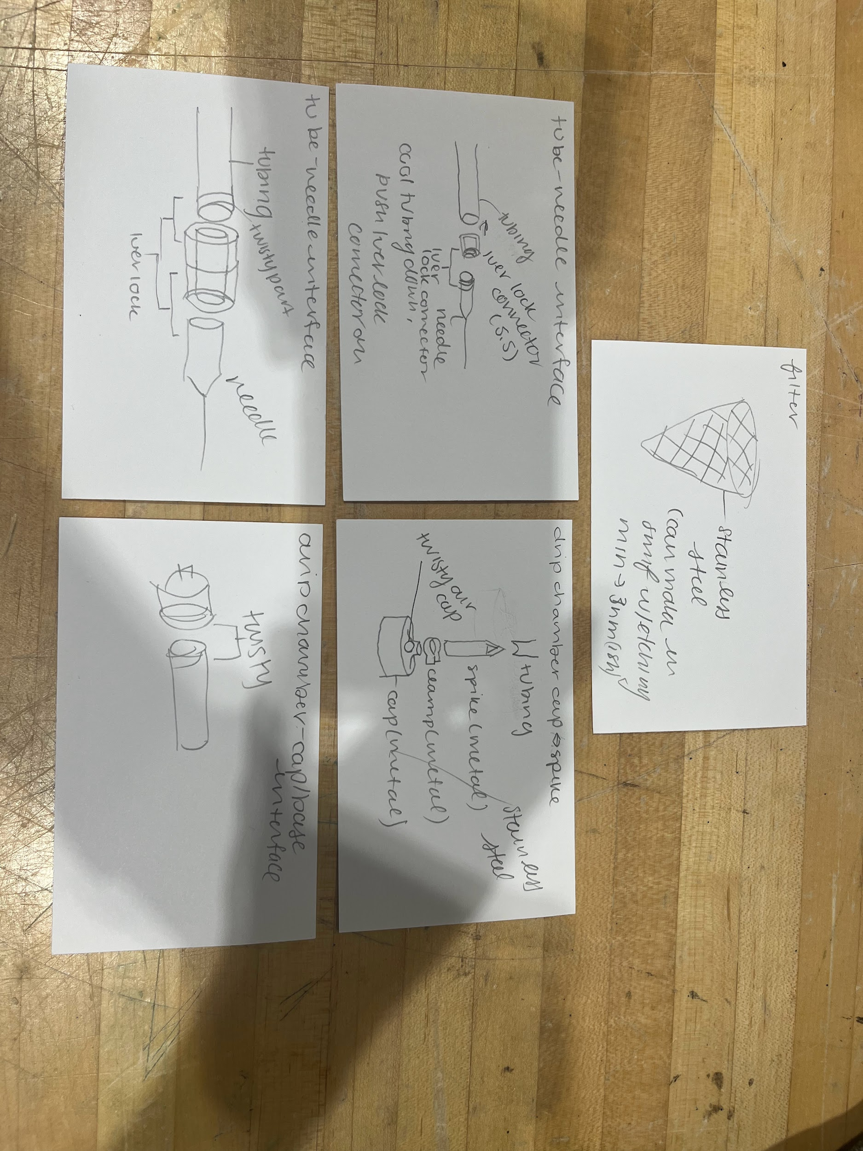

* Design 1 - Filter
  + Filter made out of metal mesh
  + Sterilizable, durable, reusable, easy to source
  + May be hard to assemble depending on how we put into drip chamber
  + Large surface area = faster blood filtration rate
* Design 2: Tube-needle interface
  + Tube- needle interface
  + Luer lock is airtight, easy to assemble, sterilizable, durable after many uses
  + Medical grade epoxy glue will ensure the strength of the connection from the tube to the luer lock
* Design 3: drip chamber cap/spike
  + Fit into each other
  + Lots of components makes it hard to assemble but improves sterilization capabilities
  + More components may mean less tight
  + Air vent not necessary if we have squishy bags
* Design 4: Tube-needle interface
  + Dual end luer lock connector with threads on tubing
  + Threads on tubing not feasible if have a bending material, would not be airtight and would be difficult to use
* Design 5: Drip chamber - cap/base interface
  + Have screw in for the cap and chamber
  + Airtight, easy to use, increases exposable surface area in autoclave
  + May have to use epoxies and additional components to finalize screw in